**TODAY’S ASSIGNMENT**

**TASK-1:**

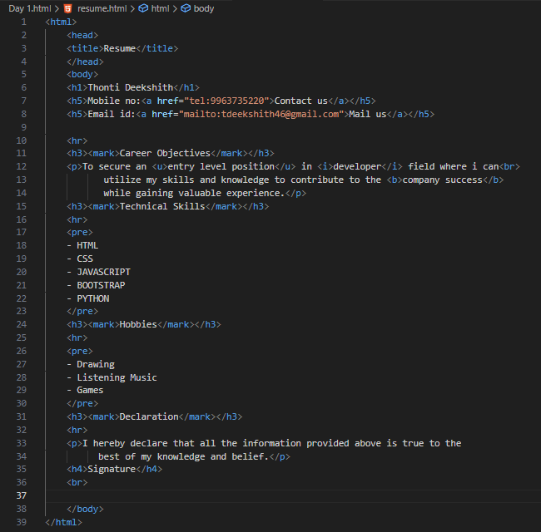

**OUTPUT:**

